**NWO Youth**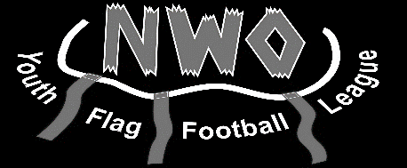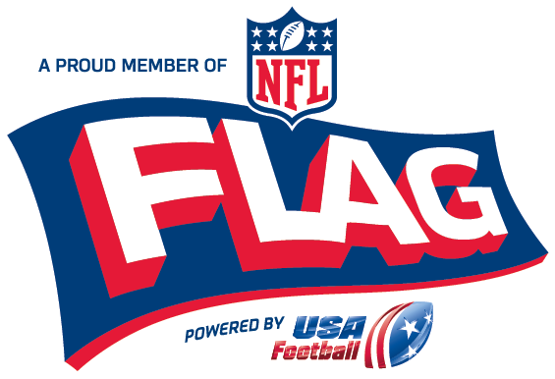

**Flag Football League**

Dear Parents,

The NWO Youth Flag Football League, a proud member of NFL Flag, will be providing your child with an opportunity to play Youth Flag Football. The NWO Youth Flag Football League is a recreational league for **boys and girls** entering grades K-4, as of August 1st of this year (5-year olds not yet entering Kindergarten **WILL** be permitted to play). The program provides young players a fun and exciting opportunity to engage in non-contact, continuous action while learning lessons in teamwork. Players will learn skills and lessons that will help them succeed both on and off the field. **Players will be split up by the school district they are attending for the upcoming school year**, allowing for local practices and less travel time for parents and players.

The game is 5-on-5 flag football, which teaches the basic skills of football; running, passing, receiving, and defending, all while maintaining non-contact rules. The rules are designed for all players to maintain equal playing time and geared toward ALL players learning ALL positions.

This is a Recreational League, score is kept, and teams practice once per week for up to 60 minutes for our lowest division (K & Under), twice per week for our 1st & 2nd Grades, and up to three times per week each up to 60 minutes for our highest division (3rd & 4th Grades). All divisions play games on Sunday for 5 weeks. Scrimmages will be held on August 25th, games begin September 8th, and all teams make the playoffs held on October 20th and a Champion will be crowned in each age group. We had three different school districts account for our three champions last year. Games may start as early as 10 a.m.

We believe the changes we made this past season were all positive changes to our league including keeping our cost at $35. Once again, we will be offering two dates for evaluations. These will be held Sunday July 21st and Sunday August 4th with the starting time dependent on your player’s grade level. We ask that players TRY to make **ONE** of the two days. Our goal is to make the teams as fair as possible. During the day, players will be tested on numerous skills used while competing in flag football. Our Board will split teams **based on the players school district** and then the results of our evaluation. If you have any questions in regards to our league, please contact us at 419-665-3524, [nwoyouthffl@gmail.com](mailto:nwoyouthffl@gmail.com), or on Facebook.

Sincerely,

The Board of Directors



Tyler Closson Brad Deleruyelle

Michael Escamilla Zach Buckland

Jay Rump Chris Kuhlman

Brad Rump

**NWO Youth Flag Football League Registration Form**

First Name: Last Name: Male / Female

Address: City:

State: Zip Code:

Birthdate: / / _ Grade: (2019-2020 School Year)

School Attending: (2019-2020 School Year)

Parent Name(s):

Main Contact Phone: _ Secondary Contact Phone: _

Email Address:

Able to Receive Text Messages: YES NO

**(CIRCLE ONE)**

Check box if you are interested or know someone who may be interested in coaching.

**\***Please provide coach's name, phone number and email below

Name: Phone: Email:

**Emergency Contact Information (Non-parent)**

Emergency Contact:

Relationship: Phone:

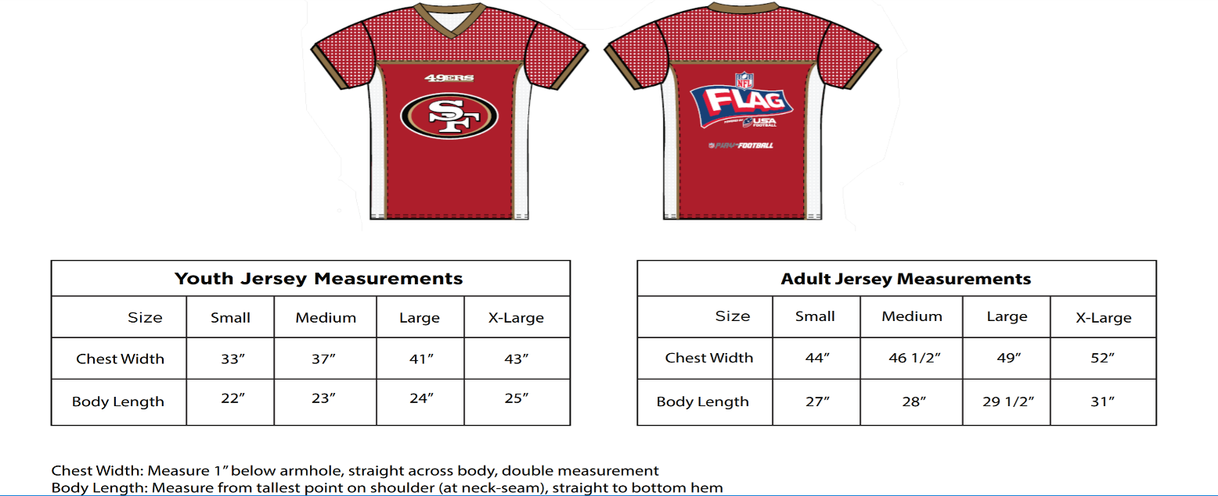**Jersey Size:**

Circle the jersey size for your child

**Do you own or know of any business that may be interested in being a league sponsor? (Sponsors receive publicity through our website and game fields.)**

Name of Potential Sponsor: Phone:

Continue on back side

**Registration Fees**

All league registration is $35. Please include Cash or Checks.

Make checks payable to **NWO Youth Flag Football League**.

Send all fees and registration forms to:

**NWO Youth Flag Football League**

**849 N. Defiance St.**

**Ottawa, OH 45875**

**Fees Include:**

Reversible NFL FLAG football jersey

NFL FLAG belt and flags

Mouthguard

Accident Insurance

USA Football Membership

** Registration will be available online starting May 1, 2019. Credit/Debit cards are accepted.

A 3.5% fee will apply.

*** Parents must go on NFL FLAG website to complete Waiver Form. Can be found at [www.nflflag.com/parents](http://www.nflflag.com/parents).

Must be done for your child to be covered under the insurance policy.

**** **Registration ends August 1, 2019. A $20 fee will be applied for late registration and walk up registration.**

We can also offer for additional fees:

Extra pair of NFL Flags - $10

Official NFL FLAG Football - $20

**Refund Policy**

**The league DOES NOT OFFER REFUNDS once the player is registered and fees are paid unless the league is unable to place the player on a team.**

**Fees returned with registration form: (Please Check One Box)**

**- $35 – Registration Fee**

**- $45 – Registration Fee + Extra Flags**

**- $55 – Registration Fee + Football**

**- $65 – Registration Fee + Extra Flags + Football**

**I authorize my child to participate in the NWO Youth Flag Football League and understand the NWO Youth Flag Football League Refund Policy.**

**Parent/Legal Guardian: Date:**

This flag football league is a proud member of NFL Flag Football, but none of the National Football League (NFL), its member clubs, NFL Ventures, L.P. or any of their respective affiliates or subsidiaries will have any liability or responsibility for any claim arising in connection with participation therein. All NFL-related logos and marks are trademarks of the NFL.